Hrvatski zavod za javno zdravstvo/Croatian National Institute of Public Health
Referentni centar Ministarstva zdravstva za dijagnostiku i praćenje virusnih zoonoza/
Reference Centre for Diagnosis and Surveillance of Viral Zoonoses Ministry of Health
Referentni centar Ministarstva zdravstva za epidemiologiju/
Reference Centre for Epidemiology Ministry of Health
Medicinski fakultet Sveučilišta u Zagrebu/School of Medicine University of Zagreb

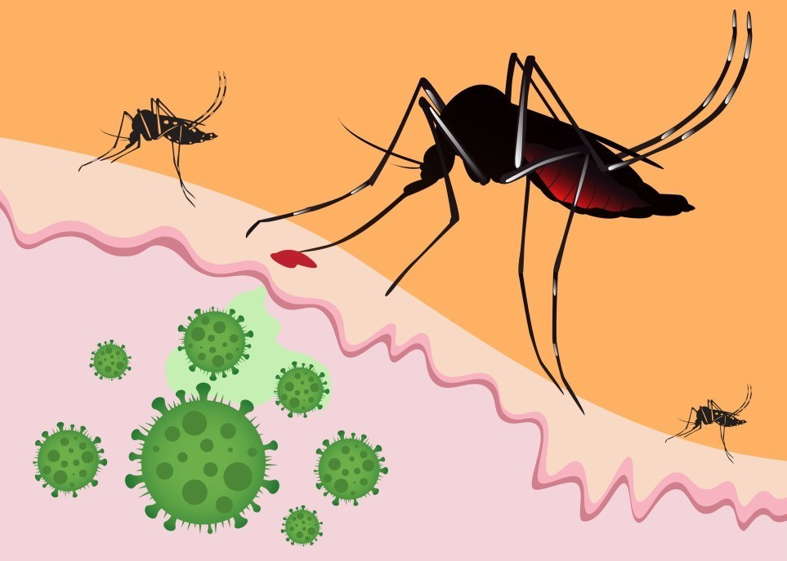
Škola narodnog zdravlja "Andrija Štampar"/Andrija Štampar School of Public Health
Veterinarski fakultet Sveučilišta u Zagrebu/Faculty of Veterinary Medicine University of Zagreb

uz potporu SZO - URED ZA HRVATSKU
ZIKA
DENGUE
TICK-BORNE ENCEPHALITIS
CHIKUNGUNYA
WEST NILE
USUTU

with support of WHO - COUNTRY OFFICE CROATIA

RADIONICA/WORKSHOP:
"Jedno zdravlje": Dijagnostika i praćenje Zika i drugih emergentnih arbovirusnih infekcija u Hrvatskoj
"One health": Diagnosis and surveillance of Zika and other emerging arboviral infections in Croatia

Voditelji/Chairs: Tatjana Vilibić-Čavlek, Bernard Kaić, Ljubo Barbić
Zagreb, 23-24. ožujak/March 2017 (Dvorana A, ŠNZ "Andrija Štampar", Rockefellerova 4)

Četvrtak/Thursday, 23.03.2017.
8.30 - 9.00 Registracija sudionika/Registration of participants
9.00 - 9.15 Otvaranje radionice/Opening, welcome

EMERGENTNE ARBOVIRUSNE INFEKCIJE - ISKUSTVA REFERENTNIH LABORATORIJA
EMERGING ARBOVIRAL INFECTIONS - EXPERIENCES OF THE REFERENCE LABORATORIES
Moderator/Chair: Antoinette Kaić-Rak
9.15 - 9.30 Report on the Zika virus - Interim Risk Assessment in the WHO European Region (Antoinette Kaić-Rak, WHO Country Office Croatia)
9.30 - 9.50 Surveillance of emerging arboviruses in Slovenia (Tatjana Avšič-Županc, Miša Korva, WHO Reference Centre for Arboviruses and Viral Hemorrhagic Fevers, Ljubljana, Slovenia) - 20 min
9.50 - 10.10 Diagnosis of arboviruses at the Italian National Reference Laboratory for Arboviruses: one year with Zika virus (Giulietta Venturi, NRL for Arboviruses, Istituto Superiore di Sanità, Roma, Italy)
10.10 - 10.30 Surveillance of emerging flaviviruses in Italy (Giovanni Savini, Federica Monaco, OIE Reference Centre for West Nile Disease, Istituto Zooprofillatico Sperimentale "G. Caporale", Teramo, Italy)
10.30 - 10.45 Rasprava/Discussion
10.45 - 11.15 Stanka za kavu/Coffee-break

EPIDEMIOLOGIJA ZIKA I DRUGIH EMERGENTNIH ARBOVIRUSNIH INFEKCIJA
EPIDEMIOLOGY OF ZIKA AND OTHER EMERGING ARBOVIRAL INFECTIONS
Moderator/Chair: Ljubo Barbić
11.15 - 11.30 Pristup "Jedno zdravlje" u nadzoru emergentnih arbovirusnih infekcija u Hrvatskoj/A "One Health" approach to emerging arboviruses surveillance in Croatia (Ljubo Barbić)
11.30 - 11.45 Epidemiologija emergentnih arbovirusnih infekcija u Hrvatskoj/Epidemiology of emerging arboviral infections in Croatia (Iva Pem-Novosel)
11.45 - 12.00 Prikaz rada Centra za cijepljenje i putničke bolesti Nastavnog zavoda za javno zdravstvo "Dr Andrija Štampar"/ Activities of Centre for Vaccination and Prevention of Travel Diseases in Zagreb Teaching Institute of Public Health "Dr Andrija Stampar" (Mirjana-Lana Kosanović Ličina)

KLINIČKI ASPEKTI I DIFERENCIJALNA DIJAGNOZA ZIKA I DRUGIH EMERGENTNIH ARBOVIRUSNIH INFEKCIJA
CLINICAL ASPECTS AND DIFFERENTIAL DIAGNOSIS OF ZIKA AND OTHER EMERGING ARBOVIRAL INFECTIONS
Moderator/Chair: Marija Santini
12.00 - 12.15 Kliničke značajke neuroinvazivnih West Nile i Usutu infekcija u Hrvatskoj/Clinical characteristics of neuroinvasive West Nile and Usutu infections in Croatia (Marija Santini)
12.15 - 12.30 Clinical characteristics of tick-borne encephalitis (Ljiljana Perić, Dario Sabadi)
Importirane arbovirusne infekcije u Hrvatskoj/Imported arboviral infections in Croatia
12.30 - 12.40 Importirane dengue infekcije u Hrvatskoj/Imported dengue infections in Croatia (Nenad Pandak, Božana Miklaušić)
12.40 - 12.50 Prva importirana Zika infekcija u Hrvatskoj, 2016/First imported Zika infection in Croatia, 2016 (Ljiljana Betica- Radić)
12.50 - 13.00 Prva importirana chikungunya infekcija u Hrvatskoj, 2016/First imported Chikungunya infection in Croatia, 2016 (Boris Lukšić, Svjetlana Karabuva)
13.00 - 13.30 Rasprava/Discussion
13.30 - 14.30 Stanka za ručak/Lunch

LABORATORIJSKA DIJAGNOSTIKA ZIKA I DRUGIH EMERGENTNIH ARBOVIRUSNIH INFEKCIJA U HRVATSKOJ
LABORATORY DIAGNOSIS OF ZIKA AND OTHER EMERGING ARBOVIRUSES IN CROATIA
Moderator/Chair: Tatjana Vilibić-Čavlek
14.30 -14.40 Serološka dijagnostika emergentnih arbovirusa, NRL za arboviruse, HZJZ/Serological diagnosis of emerging arboviruses, NRL for Arboviruses, CNIPH (Tatjana Vilibić-Čavlek)
14.40 - 14.50 Molekularna dijagnostika emergentnih arbovirusa, NRL za arboviruse, HZJZ/Molecular diagnosis of emerging arboviruses, NRL for Arboviruses, CNIPH (Andrea Babić-Erceg)
14.50 -15.05 Molekularna dijagnostika emergentnih arbovirusa u Klinici za infektivne bolesti "Dr Fran Mihaljević"/ Molecular diagnosis of emerging arboviruses - University Hospital for Infectious Diseases "Dr Fran Mihaljević" (Ivan Christian Kurolt, Alemka Markotić)
15.05 - 15.15 Dijagnostika Zika i ostalih emergentnih arbovirusa u putnika povratnika iz endemskih područja/Diagnosis of Zika and other emerging arboviruses in travelers returning from endemic areas (Irena Tabain)
15.15 - 15.30 Rasprava/Discussion
15.30 - 16.30 Obilazak NRL za arboviruse, HZJZ/Visit to NRL for Arboviruses, CNIPH

Petak/Friday, 24.03.2017.
OKRUGLI STOL: PRAĆENJE ZIKA I DRUGIH ARBOVIRUSNIH INFEKCIJA U HRVATSKOJ
ROUND TABLE: MONITORING OF ZIKA AND OTHER EMERGING ARBOVIRUSES IN CROATIA
Moderator/Chair: Josip Madić
9.00 - 9.15 Invazivni komarci u Hrvatskoj - širenje i trenutna rasprostranjenost/Invasive mosquito species in Croatia - spreading and current distribution (Ana Klobučar)
9.15 - 9.30 Provedba nacionalnog sustava praćenja invazivnih vrsta komaraca u Hrvatskoj/Implementation of the national monitoring of invasive mosquito species in Croatia (Nataša Janev-Holcer)
9.30 - 9.45 Sustavi kontrole virusa Zapadnog Nila/Surveillance systems of West Nile virus (Vladimir Stevanović)
9.45 - 10.00 Monitoring infekcije divljih ptica i domaće peradi virusom Zapadnog Nila/Monitoring of West Nile virus infection in wild birds and domestic poultry (Vladimir Savić)
10.00 - 10.15 Virus krpeljnog encefalitisa u krpelja odvojenih s lisica/Tick-borne encephalitis virus in ticks derived from foxes (Lorena Jemeršić)
10.15 - 11.00 Rasprava/Discussion
11.00 - 12.00 Stanka za kavu/Coffee-break

PREVENCIJA EMERGENTNIH ARBOVIRUSNIH INFEKCIJA
PREVENTION OF EMERGING ARBOVIRAL INFECTIONS
Moderator/Chair: Bernard Kaić
12.00 - 12.15 Značaj emergentnih arbovirusa u transfuzijskoj medicini/Significance of emerging arboviruses in transfusion medicine (Manuela Miletić)
12.15 - 12.30 Preporuke za putnike u područja cirkulacije arbovirusa/Recommendations for travelers in the areas of arboviruses circulation (Goranka Petrović)
12.30 - 12.45 Cijepljenje protiv emergentnih arbovirusnih infekcija/Vaccination against emerging arboviral infections (Bernard Kaić)
12.45 - 13.00 Mjere sprečavanja zaraznih bolesti koje prenose komarci/Preventive measures for mosquito-borne diseases (Pavle Jeličić)
13.00 - 14.00 Usklađena rasprava. Zaključci. Zatvaranje radionice/Group discussion. Conclusions. Closing.

